Introduction
FG-B0H2 product is a device with routing function for a family, SOHO user-oriented GPON ONU, LAN Switch, IPTV and other functions for broadband network construction.
FG-B0H2 provides comprehensive QoS functions for high-speed Internet connection access, IPTV video on demand and live access, and voice calls. Provides more secure wireless encryption and a powerful firewall that prevents unauthorized users from accessing the network and keeping users safe. Provide TR-069 network management protocol to achieve comprehensive remote network management.
FG-B0H2 equipment uses computer network technology and broadband optical network access technology to establish a home network center, which connects various home appliances and devices in the home to share Internet network connections, providing secure wired or wireless communication and video access service.

Applications
- SOHO
- Small enterprise
- IPTV
- High-speed broadband sharing
- Broadband Internet access
- Audio, video streaming and transmission
- PC files are Shared with applications
- Surfing the internet and online game

Features
- 1*Gpon port
- 4*GE port
- 1*FXS port
- 1*USB port
- Friendly web configuration interface GUI
- Support IPSec VPN
- Port trigger function is supported to automatically open specific ports of various games and applications
- Configurable DHCP server
- Compatible with standard network applications
- Support Virtual Server, IP Filter, DMZ Host, etc.
- A simple web page for the system configuration status is displayed and connected to the configuration page
- Support AUTO, PAP, CHAP, MS-CHAP authentication.
- Support PPPOE

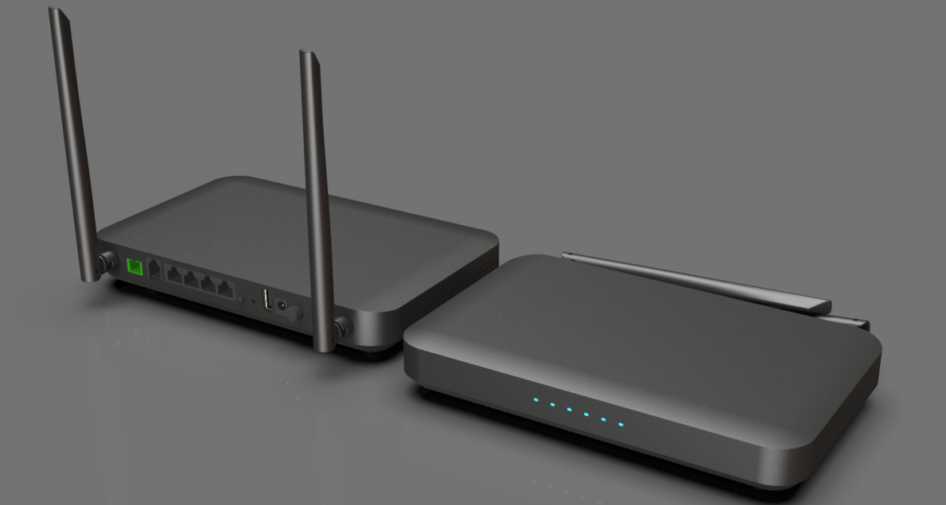
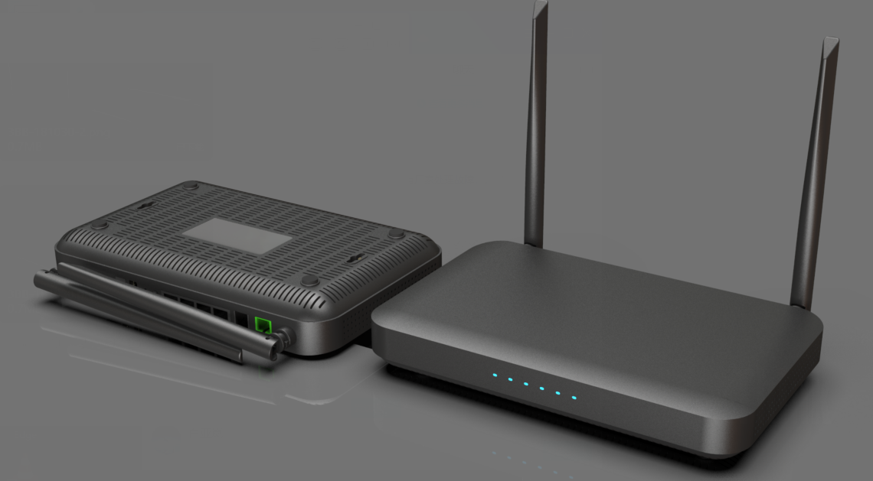

ONU interfaces and buttons are described as the following table:
Interface | Instructions
FXS | A telephone line interface used to connect telephones.
LAN1/LAN2/LAN3/LAN4 | Rj-45 GE Ethernet interface used to connect the Ethernet interface of the computer.
WPS | WPS button, one button free connection function.
RESET | Restore the factory Settings button.
USB | USB Host interface for connecting USB interface storage devices.
POWER | 12 V DC power input interface to connect the power adapter.
ON/OFF | A power switch used to connect or disconnect a device's power supply.

